In This Issue:
- Orvis Fly Rod Raffle
- July 21st Skeet Shoot results
- Washington County Fair
- Save the Dates
- Donate
- Volunteer

Hello everyone!
August is here and so are the fairs. Before you know it, the kids will be back in school and then it’s on to pumpkin spice everything. OAAs will be at the Washington County Fair, same spot across from the 4-H booth. Also, don’t forget to sign up for our upcoming trip to Foxwoods in September. And as always, “God bless our troops!”.

O
ur next Monthly Meeting will be held at our building on Monday, August 5th at 6:30 pm and the next Board of Director’s meeting will be Wednesday, September 25th at 6:30pm. Anyone interested in helping our deployed soldiers or volunteering, come on down! We can always use the help!

A New Raffle

Operation Adopt a Soldier is holding a new raffle! The winner will receive a NEW ORVIS RECON 9’ 5 Wt. Rod and case with a NEW Battenkill Disc II Reel. That’s a $400+ value. And the best thing, tickets are only $5. That’s right, $5. And we’re only selling 200 tickets. The raffle drawing will be held on November 10, 2019 at our Honor our Veteran’s Brunch at Fortune’s Restaurant at the Saratoga Casino and Hotel. If you would like to buy a raffle ticket, you can send a SASE, with a check for $5 and a note stating you would like to buy a raffle, and we’ll send you your ticket. You can also contact Cliff at 518-260-9922.

OAAS Skeet Shoot

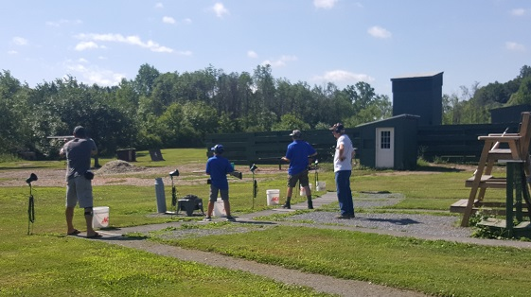
On July 21st, OAAS held it’s 6th Annual Skeet shoot at the Hudson Falls Fish and Game Club. And as luck would have it, it was THE brutally hot weekend when the thermometer and humidity made it about 105 degrees in the shade. And we melted. But the diehards showed up and we spent 3 hours shooting clays, and then had a nice BBQ lunch. Hopefully next year, the weather will co-operate. Till then….

August Happenings:
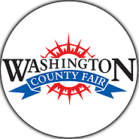
Washington County Fair

August 19th ~25th

It’s Fair Time! Once again, we’ll be at the Washington County fair selling tee-shirts, stickers, and spreading the word about our organization. Face painting too, so stop by with the kids! We’ll be at our normal spot across from the 4-H booth. Hope to see you there!

Save the Dates:
Bus Trip to Foxwoods

Save the Date ~ SIGN UP NOW!!!
September 15th, 2109

We’re going to Foxwoods! Yes, that’s right.

$40.00 PER PERSON INCLUDES:
RIDE-TO AND FROM Foxwoods Casino.

$10 FREE PLAY and FREE buffet.

We play BINGO and games on the way to Connecticut.

We will be leaving Wilton Mall near Dick’s Sporting Goods-
Light Pole C-2 at 6:30am Sharp!

YOU MUST BE PAID BY August 26, 2019 OR you will be taken off the list.

For reservations or details call: Cliff at 518-260-9922 or Sherry at 518-522-2472

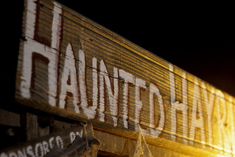
OAAS & John Vincek Memorial Haunted Hayride
This Photo by Unknown Author is licensed under CC BY-NC
Save the Date ~
October 18th, 19th, 25th, 26th, 2019

5 pm to 10 pm at Gavin Park (10 Lewis Dr), Wilton NY
The John Vincek Memorial Haunted Hayride
presented by Operation Adopt a Soldier will be here before you know it. 4pm to 6pm is the “Little
Screamers” hayride when there are no scary beings
in the woods. The spookiness starts at dark. There
will also be games in the gym (tickets sold
separately), a bounce house and costume judging at 7 pm. PROCEEDS WILL BENEFIT THE JOHN VINCEK MEMORIAL FUND
and OPERATION ADOPT A SOLDIER. Sponsored
by Vincek Farms and John Ariel Farm. The cost is
just $8 for the little screamers and $15 for adults. If
you have questions, call Cliff 518-260-9922 or
Sherry 518-522-2472 or Lynette 518-222-1091.

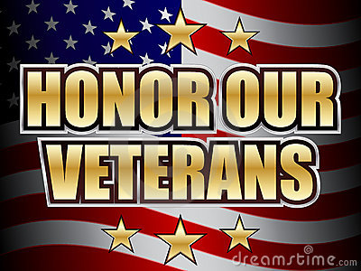
Honor Our Veterans Luncheon
This Photo by Unknown Author is licensed under CC BY-SA
Save the Date ~
November 10th, 2019

Join Operation Adopt a Soldier at our Honor Our Veterans Buffet Brunch held at Fortune’s Restaurant at the Saratoga Casino and Hotel. Come out for a monring filled with good food,; enteratinment and amazing company as we honor all those military men and women who served the USA. There will be basket raffles, a 50/50, and harness horse racing! Tickets will be avaible as we get closer to the date. Call Cliff at 518-260-9922 for details.

Ways to Donate:

Want to Donate? Listed below are several easy ways.

We are always in need of items to send overseas. Done with the new book? Cleaning out your kitchen cabinet of impulse buys? On a diet for the new year? Consider donating them to OAS. A few of the many items that are requested by our soldiers stationed overseas: toothpaste, wet wipes, lotions, books, stationary, hard candy, deodorant, chaps tick, spaghetto’s, razors, gum, journals, pens, magazines, Q-tips, sun screen, band-aids, trail mix, etc. See our website for a detailed list.

- Amazon Smile: Shop on Amazon Smile (smile.amazon.com) and they will donate 0.5% of the price of eligible purchases to the charitable organization selected by you. And remember in November Amazon starts their Black Friday Deals!

- Drop us a Check in the mail. Our address is:
Operation Adopt a Solder
4281 Rt. 50
Saratoga Springs, NY 12866

- Gather food, personal products, books, and DVDs from your friends and coworkers and drop them off at our building. For a complete list of items needed go to our website.

- GE Matching Gifts Program: Available to GE employees and retirees in their personal donations to charities. Donate $25 or more and then register your gift on the matching gifts web site that is available via GEBENEFITS.COM under the additional benefits heading. First timers must register their email address and receive confirmation. Forward this to Cliff at wiseeagle1@yahoo.com and he’ll watch for your check. Not computer savvy? Then call 1-800-305-0669 and have your SSo# ready to register by telephone.

Volunteer
Bored with life? Feel like you should be giving back? Then look no farther! We are always looking for volunteers to help with our events and pack ups. Don’t have time? Then donations are always good too, lol! Each package we send overseas costs of $15.00 in postage. Yes, $15!! Then multiply that by the number of packages we send. Cost of doing “business”. And Yikes!! So, every dollar counts!
Just hit up our improved website,
www.operationadoptasoldier.org to donate or learn how to volunteer!
And remember!
You can always follow us on Facebook, Twitter, or Snapchat or Find Us on Instagram!

