In This Issue:
- September’s Events
- October happenings – Harvest Event
- Save the Dates
- Donate
- Volunteer

Happy October everyone!

Fall is finally here and that means its time for our Harvest Event. This year’s event will be on October 19, 20, 26, and 27th. See below for more details. Also, tickets are on sale now for our Honor our Veterans Brunch on November 11th at Fortunes restaurant at Saratoga Casino. Don’t forget to check out our Save-the-dates. And as always, “God bless our troops!”.

O
ur Monthly Meeting was be held at our building (4281 Rte. 50, Wilton) on Monday, November 5th at 6:30 pm. Out next pack will be announced soon. Anyone interested in helping our deployed soldiers or volunteering, come on down! We can always use the help!

September’s Events:
On Sunday, September 16th, OAS has a bus trip to Mohegan Sun in Connecticut. We had 2 buses that left Wilton at 6:30am and didn’t return until about 9:30 pm. On the trip out we played a fun scavenger hunt game, “What’s in your pocket or purse?” 20 items later, and one side of the bus won an extra ticket for the envelope give-a-ways. A quick pit stop on the Mass. Pike and then it was several games of BINGO. Before we knew it, Mohegan Sun, here we are! Several hours and thousands of dollars later, we were back on the bus and headed home. Movies were popped into the dvd players, and the tired leaned against the windows or seats and closed their eyes. And before we knew it we were dropped off back in Wilton. There were winners. There were losers. And there were memories made. Until the next casino bus trip.

On September 9th, Phil Hoyt held his 7th annual OAS Benefit concert at the Veteran’s park in Granville, NY. What a wonderful day it was, sitting in the park, listening to country music. And what can be better? Not much, lol. By the beginning of October Phil had collected all of his dontations from the event and travelled to Wilton for our monthly meeting. There he presented our president, Gordon Dilmore, with a check for $3,240.00! OAS would like to give Phil and his family a huge thank you for all the hard work that they put in to this event! With out them, there would be no concert.

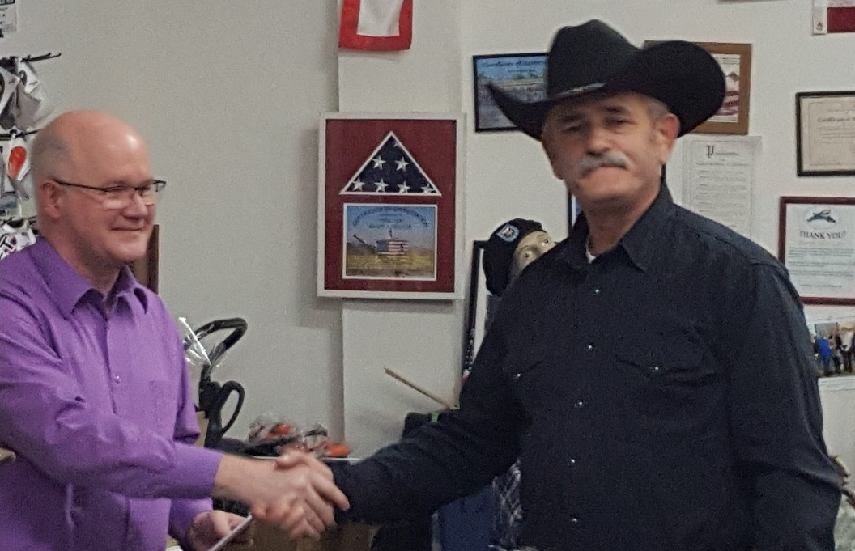

October’s Events:

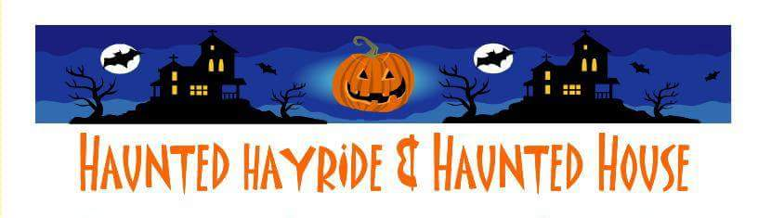
Annual Harvest Event
Save the Date ~
October 19th & 20th and 26th & 27th
5 pm to 10 pm at Gavin Park (10 Lewis Dr) Wilton NY
The John Vincek Memorial Haunted Hayride presented by Operation Adopt a Soldier is only a few weeks away. 4pm to 6pm is the “Little Screamers” hayride when there are no scary beings in the woods. The spookiness starts at dark. There will also be games in the gym (tickets sold separately), a bound house, face painting, and a costume judging at 7 pm. PROCEEDS WILL BENEFIT THE JOHN VINCEK MEMORIAL FUND and OPERATION ADOPT A SOLDIER. Sponsored by Vincek Farms and John Ariel Farm. The cost is just $8 for the little screamers and $12 for adults. If you have questions, call Cliff 518-260-9922 or Sherry 518-522-2472 or Lynette 518-222-1091. Rain or Shine

Save the Dates:

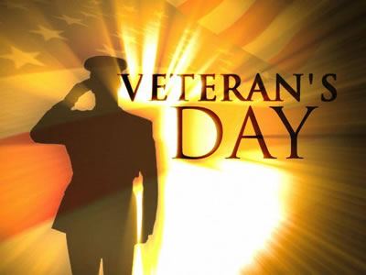
Honor Our Veterans Luncheon
Save the Date ~

November 11th

Join Operation Adopt a Soldier at our Honor Our Veterans Buffet Brunch held at Fortune's Restaurant at Saratoga Casino and Hotel. Come out for a morning filled with good food, entertainment, and amazing company as we honor all those military men and women who served the USA. There will be basket raffles, 50/50, and harness horse racing!
The cost is $25 per ticket or $30 at the door. We suggest purchasing tickets a head of time.
Tickets are on sale now!! Call Mary at 518-495-6613.
Hope to see you there!

This Photo by Unknown Author is licensed under CC BY-NC
Annual Golf Tournament
Save the Date ~
June 1, 2019

For details call Tim at 518-791-5270 or email ratherbgolfing247@roadruner.com

Ways to Donate:

Want to Donate? Listed below are several easy ways.

We are always in need of items to send overseas. Done with the new book? Cleaning out your kitchen cabinet of impulse buys? On a diet for the new year? Consider donating them to OAS. A few of the many items that are requested by our soldiers stationed overseas: toothpaste, wet wipes, lotions, books, stationary, hard candy, deodorant, chaps tick, spaghetto’s, razors, gum, journals, pens, magazines, Q-tips, sun screen, band-aids, trail mix, etc. See our website for a detailed list.

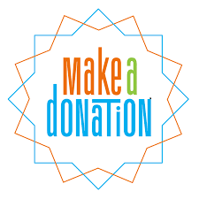

- Amazon Smile: Shop on Amazon Smile (smile.amazon.com) and they will donate 0.5% of the price of eligible purchases to the charitable organization selected by you. And remember in November Amazon starts their Black Friday Deals!

- Drop us a Check in the mail. Our address is:
Operation Adopt a Solder
4281 Rt. 50
Saratoga Springs, NY 12866

- Gather food, personal products, books, and DVDs from your friends and coworkers and drop them off at our building. For a complete list of items needed go to our website.

- GE Matching Gifts Program: Available to GE employees and retirees in their personal donations to charities. Donate $25 or more and then register your gift on the matching gifts web site that is available via GEBENEFITS.COM under the additional benefits heading. First timers must register their email address and receive confirmation. Forward this to Cliff at wiseeagle1@yahoo.com and he’ll watch for your check. Not computer savvy? Then call 1-800-305-0669 and have your SSo# ready to register by telephone.

Volunteer
Bored with life? Feel like you should be giving back? Then look no farther! We are always looking for volunteers to help with our events and pack ups. Don’t have time? Then donations are always good too, lol! Each package we send overseas costs of $15.00 in postage. Yes, $15!! Then multiply that by the number of packages we send. Cost of doing “business”. And Yikes!! So, every dollar counts!
Just hit up our improved website,
www.operationadoptasoldier.org to donate or learn how to volunteer!
And remember!
You can always follow us on Facebook, Twitter, or Snapchat or Find Us on Instagram!

