In This Issue:
- NEW TEMPORAY ADDRESS
- OAS head -quarters Fire
- Orvis Fly Rod Raffle
- September Events
- Save the Dates
- Donate
- Volunteer

Hello everyone.
On August 17th OAAS suffered a devastating fire that resulted in a total loss of our building. We have found a temporary home at 891 Saratoga Road, in Wilton NY. We are still accepting donations and are trying to get back up and running as soon as we can. We give our thanks to the responding fire departments, the Town of Wilton and all the volunteers that have helped us get to our new location. And as always, “God bless our troops!”.

O
ur next Monthly Meeting will be held on Monday, September 9th at 6:30 pm at our NEW TEMPORARY LOCATION at 891 Saratoga Road in Wilton. This is the old Farrell Oil warehouse building at the corner of Rt. 9 & Ballard Road at the base of Wilton Mountain near exit 16. Doors are located near the back so please drive around the building. The next Board of Director’s meeting will be Wednesday, September 25th at 6:30pm. Anyone interested in helping our deployed soldiers or volunteering, come on down! We are starting to get our woods ready for haunting. We need volunteers to clean up the woods and build haunts. If you and a few of your friends are Halloween enthusiasts and love to create eerie and scary props, then we need you! We’re always looking for new ideas!

Operation Adopt A Soldier building destroyed by fire -August 17th

The August 17th fire damaged the inside of the building, including more than 260 packages that were ready to be mailed to U.S. troops

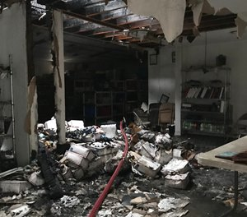
- Excerpts Taken from Times Union, Albany, N.Y.
WILTON, N.Y. — A Saturday afternoon fire destroyed a building that housed a family of four as well as a not-for-profit that collects donations to send to U.S. soldiers overseas.
The organizers at Operation Adopt A Soldier, 4281 Route 50, said the fire started in the building's utility room; the building also has another business and an apartment in it.
"We basically lost everything, it's a total loss," said the organization's director Cliff Seguin on Sunday.
The fire damaged the inside of the building — including more than 260 packages that were ready to be mailed to U.S. troops, the non-profit said in a news release it posted on its website.
Seguin said the fire happened just weeks before the nonprofit's busiest time of the year, where it ramps up collections to ensure military personnel get packages for the holidays.
Firefighters were able to save two American flags that had signatures of military personnel on them.
Operation Adopt A Soldier is accepting donations at any Saratoga National Bank or Glens Falls National Bank branch, and also has a Gofundme page for donations.
Operation Adopt A Soldier officials said in 2015 it sent packages to more than 500 troops serving overseas. Letters, snacks and games are mailed at least once a month to every soldier, sailor, airmen or marine on their list.
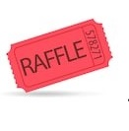
Orvis Fly Rod & Reel Raffle

Operation Adopt a Soldier is holding a new raffle! The winner will receive a NEW ORVIS RECON 9’ 5 Wt. Rod and case with a NEW Battenkill Disc II Reel. That’s a $400+ value. And the best thing, tickets are only $5. That’s right, $5. And we’re only selling 200 tickets. The raffle drawing will be held on November 10, 2019 at our Honor our Veteran’s Brunch at Fortune’s Restaurant at the Saratoga Casino and Hotel. If you would like to buy a raffle ticket, you can send a SASE, with a check for $5 and a note stating you would like to buy a raffle, and we’ll send you your ticket. You can also contact Cliff at 518-260-9922.

September Happenings:
Bus Trip to Foxwoods
September 15th, 2109

$40.00 PER PERSON INCLUDES:
RIDE-TO AND FROM Foxwoods Casino.

$10 FREE PLAY and FREE buffet.

We play BINGO and games on the way to Connecticut. We will be leaving Wilton Mall near Dick’s Sporting Goods- Light Pole C-2 at 6:30am Sharp!

For reservations or details call: Cliff at 518-260-9922 or Sherry at 518-522-2472

Save the Dates:

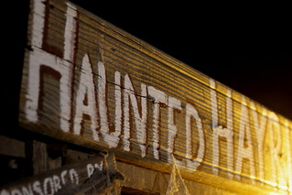
OAAS & John Vincek Memorial Haunted Hayride
This Photo by Unknown Author is licensed under CC BY-NC
Save the Date ~
October 18th, 19th, 25th, 26th, 2019

5 pm to 10 pm at Gavin Park (10 Lewis Dr), Wilton NY
The John Vincek Memorial Haunted Hayride
presented by Operation Adopt a Soldier will be here before you know it. 4pm to 6pm is the “Little
Screamers” hayride when there are no scary beings
in the woods. The spookiness starts at dark. There
will also be games in the gym (tickets sold
separately), a bounce house and costume judging at 7 pm. PROCEEDS WILL BENEFIT THE JOHN VINCEK MEMORIAL FUND
and OPERATION ADOPT A SOLDIER. Sponsored
by Vincek Farms and John Ariel Farm. The cost is
just $8 for the little screamers and $15 for adults. If
you have questions, call Cliff 518-260-9922 or
Sherry 518-522-2472 or Lynette 518-222-1091.

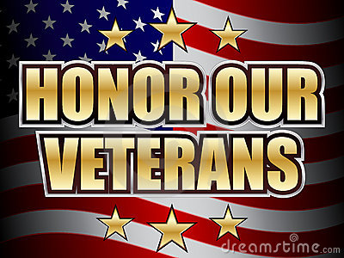
Honor Our Veterans Luncheon
This Photo by Unknown Author is licensed under CC BY-SA
Save the Date ~
November 10th, 2019

Join Operation Adopt a Soldier at our Honor Our Veterans Buffet Brunch held at Fortune’s Restaurant at the Saratoga Casino and Hotel. Come out for a monring filled with good food,; enteratinment and amazing company as we honor all those military men and women who served the USA. There will be basket raffles, a 50/50, and harness horse racing! Tickets will be avaible as we get closer to the date. Call Cliff at 518-260-9922 for details.

Ways to Donate:

Want to Donate? Listed below are several easy ways.

We are always in need of items to send overseas. Done with the new book? Cleaning out your kitchen cabinet of impulse buys? On a diet for the new year? Consider donating them to OAS. A few of the many items that are requested by our soldiers stationed overseas: toothpaste, wet wipes, lotions, books, stationary, hard candy, deodorant, chaps tick, spaghetto’s, razors, gum, journals, pens, magazines, Q-tips, sun screen, band-aids, trail mix, etc. See our website for a detailed list.

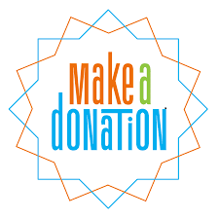

- Amazon Smile: Shop on Amazon Smile (smile.amazon.com) and they will donate 0.5% of the price of eligible purchases to the charitable organization selected by you. And remember in November Amazon starts their Black Friday Deals!

- Drop us a Check in the mail. Our address is:
Operation Adopt a Solder
4281 Rt. 50
Saratoga Springs, NY 12866

- Gather food, personal products, books, and DVDs from your friends and coworkers and drop them off at our building. For a complete list of items needed go to our website.

- GE Matching Gifts Program: Available to GE employees and retirees in their personal donations to charities. Donate $25 or more and then register your gift on the matching gifts web site that is available via GEBENEFITS.COM under the additional benefits heading. First timers must register their email address and receive confirmation. Forward this to Cliff at wiseeagle1@yahoo.com and he’ll watch for your check. Not computer savvy? Then call 1-800-305-0669 and have your SSo# ready to register by telephone.

Volunteer
Bored with life? Feel like you should be giving back? Then look no farther! We are always looking for volunteers to help with our events and pack ups. Don’t have time? Then donations are always good too, lol! Each package we send overseas costs of $15.00 in postage. Yes, $15!! Then multiply that by the number of packages we send. Cost of doing “business”. And Yikes!! So, every dollar counts!
Just hit up our improved website,
www.operationadoptasoldier.org to donate or learn how to volunteer!
And remember!
You can always follow us on Facebook, Twitter, or Snapchat or Find Us on Instagram!

