In This Issue:

- Package update
- Saratoga National Cemetery Event
- Raffles
- Save the Dates
- Donate
- Volunteer

Happy June everyone!

It’s hard to believe that the year is half over with and graduations are just around the corner. Our summer events are starting to get closer so look at the save the dates. Lots of things going on… and as Cliff always says, “God bless our troops!”

O
ur Monthly Meeting will be held at our building (4281 Rte. 50, Wilton) on Monday, June 4th at 6:30 pm. At this time, we do not have any pack ups scheduled for June. Anyone interested in helping our deployed soldiers or volunteering, come on down! We can always use the help!

Package Update:

Well, its June. Remember, postage has gone up, so our costs have increased. During our last pack up, we sent over 150 packages out for a cost of $2,500. Our shelves are bare, again, so any donations are greatly appreciated. See below, under the Donation header, to see what is needed. Stay tuned for our July pack-up date.

May Events:
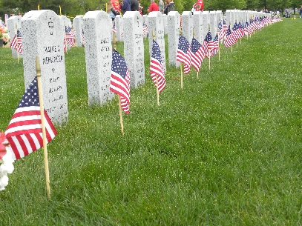
Saratoga National Cemetery
On Saturday, May 26th, Operation Adopt a Soldier joined hundreds of volunteers to place flags on our fallen heroes’ graves at the Gerald B.H. Solomon Saratoga National Cemetery. After an opening ceremony, volunteers walked over to section 6 and armed with a short explanation of what to do, they started to place the flags. There are over 18,000 graves at this site, and flags are placed on each one. The work is done in a few hours, and then people wander off. Five days later, the flags are picked back up, counted, and stored for next year.
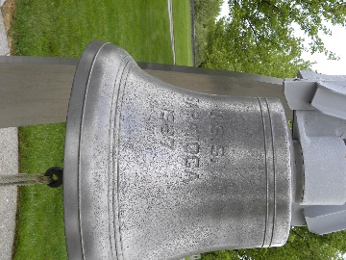
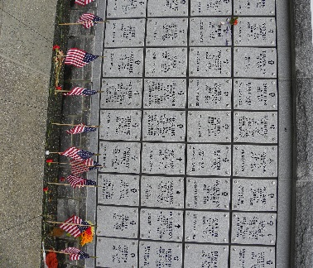

Attention all Rifle and Crossbow Enthusiasts!

We now have 2, yes 2, raffles for you!
Raffle 1
Oaas is selling raffle tickets for a .17 HMR Henry Goldenboy rifle OR Mossberg Patriot 30-06. The tickets are $20 and only 250 will be sold.
Raffle 2
Raffle tickets for an Inferno Blitz II Compact Crossbow package. The tickets are $10 and only 120 will be sold.

If you’re interested in purchasing a ticket, please give Jason (518-935-7859) or Sharon (518-935-7549) a call. Both drawings will take place at Hudson Falls Fish and Game at our Skeet shoot on July 22nd. Winner is responsible for transfer fees and taxes if applicable. Transfer done at Beecroft’s Shooters Supply of Schaghticoke.

Save the Date
June 9th
This Photo by Unknown Author is licensed under CC BY-NC-SA
OAAS will be walking in the Saratoga Flag Day Parade. Lineup is at 11 am.

PARKFEST
July 7th Wilton’s Community Day Park Fest
OAAS will be at Wilton’s Community Day Park Fest at 9 am. Free Admission and lots of games and rides!

Attention all Trap & Skeet Shooters!
Save the Date ~ Sunday, July 22nd
Operation Adopt a Soldier is hosting its 5th annual Benefit Skeet and Trap Shoot at Hudson Falls Fish & Game Club on Sunday, July 22nd and we’re selling raffle tickets too! Last year’s shoot was a rip-roaring success!! NYS Assemblywoman Carrier Woerner even came and shot skeet. Hopefully she’ll be back this year. Who doesn’t like to have fun and shoot at the same time! The cost is $5 per person per game. You provide your own ammo, gun, and ear/eye protection. And best of all, all proceeds go to OAAS. Call Jason at 518-935-7859 for details! See you there!

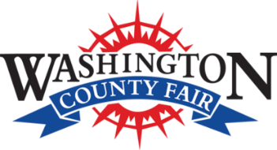
Attention all Fair Goers!!!
August 20 to August 26h

Once again, Operation Adopt a Soldier will be at the Washington County Fair, across from the green 4-H building. We will be doing face painting for a $5 donation and will be selling our shirts, hats, sweatshirts and are always willing to accept donations for sponsoring a box to a soldier. Stop in and see us. We can’t wait to see you at the fair!

Mohegan Sun Casino Trip

September 16th

Operation Adopt a Soldier is chartering a bus to Mohegan Sun Casino on September 16th. The bus will be waiting by the C-2 light pole by Dick's Sporting Goods and we will be leaving at 6:30 a.m. sharp. Please do not be late, we have a strict time schedule at make it to the casino by 11 a.m. There will be bingo games and tons of prizes on the way down, so make sure to bring all your luck with you! The best part...all proceeds go to Operation Adopt a Soldier and our Heroes serving overseas.

Call Cliff at 518-260-9922 to reserve your spot today!

Ways to Donate:

Want to Donate? Listed below are several easy ways.

We are always in need of items to send overseas. Done with the new book? Cleaning out your kitchen cabinet of impulse buys? On a diet for the new year? Consider donating them to OAS. A few of the many items that are requested by our soldiers stationed overseas: toothpaste, wet wipes, lotions, books, stationary, hard candy, deodorant, chaps tick, spaghetto’s, razors, gum, journals, pens, magazines, Q-tips, sun screen, band-aids, trail mix, etc. See our website for a detailed list.

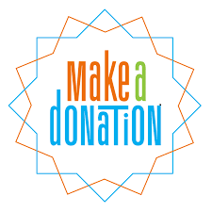

- Amazon Smile: Shop on Amazon Smile (smile.amazon.com) and they will donate 0.5% of the price of eligible purchases to the charitable organization selected by you. And remember in November Amazon starts their Black Friday Deals!

- Drop us a Check in the mail. Our address is:
Operation Adopt a Solder
4281 Rt. 50
Saratoga Springs, NY 12866

- Gather food, personal products, books, and DVDs from your friends and coworkers and drop them off at our building. For a complete list of items needed go to our website.

- GE Matching Gifts Program: Available to GE employees and retirees in their personal donations to charities. Donate $25 or more and then register your gift on the matching gifts web site that is available via GEBENEFITS.COM under the additional benefits heading. First timers must register their email address and receive confirmation. Forward this to Cliff at wiseeagle1@yahoo.com and he’ll watch for your check. Not computer savvy? Then call 1-800-305-0669 and have your SSo# ready to register by telephone.

Volunteer
Bored with life? Feel like you should be giving back? Then look no farther! We are always looking for volunteers to help with our events and pack ups. Don’t have time? Then donations are always good too, lol! Each package we send overseas costs of $15.00 in postage. Yes, $15!! Then multiply that by the number of packages we send. Cost of doing “business”. And Yikes!! So, every dollar counts!
Just hit up our improved website,
www.operationadoptasoldier.org to donate or learn how to volunteer!
And remember!
You can always follow us on Facebook, Twitter, or Snapchat or Find Us on Instagram!

