In This Issue:
- Package update
- Memorial Day Saratoga National Cemetery
- June 1st Golf Event
- Save the Dates
- Donate
- Volunteer

Hello everyone!
Can you believe it’s June already and we’re halfway through the year? The beginning of June brought us our 4th annual golf tournament and in July is our 6th annual skeet shoot. So, tell all your friends! And we’ll be at the Washington County Fair in August. As always, “God bless our troops!”.

O
ur Monthly Meeting will be held at our building on Monday, June 3rd at 6:30 pm and our next Board of Director’s meeting will be Wednesday, June 12th at 6:30pm. The next monthly meeting will be August 5th. Anyone interested in helping our deployed soldiers or volunteering, come on down! We can always use the help!

Package Update:

We’ve had 2 pack-ups in the last few weeks. On May 18th, OAAS sent out 201 region B boxes and a few others, for a cost of $2,270.75. Yes, that’s the right price. And on Sunday, June 2nd, Operation Adopt a Soldier held a pack-up with Girl Scout Troop #3232 and below are some pictures. Our shelves are getting bare, so any donations are appreciated.

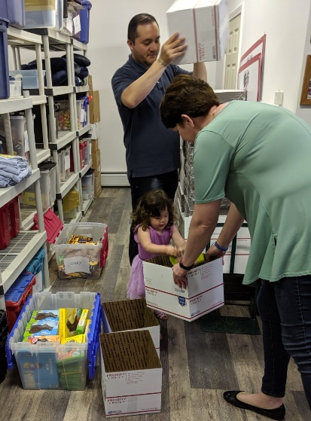
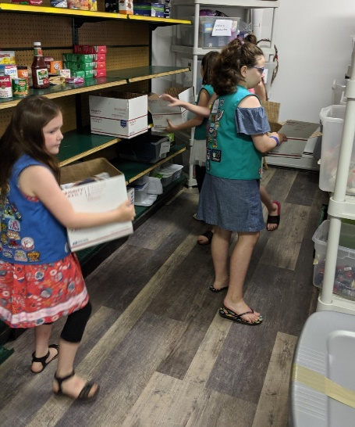

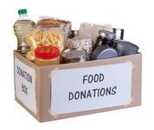
Just some additional news about a new donation site. A donation box for OAAS has been set up at BJ’s Wholesale Club’s Saratoga location. It is just inside the entrance, so grab some extra goodies and throw them in on the way out! Our soldiers love getting boxes!

Memorial Day at Saratoga National Cemetery

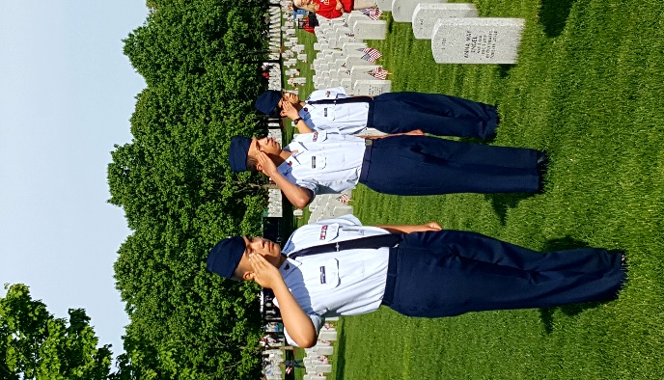
On May 25th, Operation Adopt a Soldier joined hundreds of volunteers to place flags on our fallen heroes’ graves at the Gerald B.H. Solomon Saratoga National Cemetery. Over 15,800 flags were placed in front of headstones and before the walls on that solemn morning. With over 800 funerals per year, it’s a busy cemetery, and will only be getting busier as our WW2 veterans’ pass. When I joined OAAS in 2014, I participated in this flag event. At that time, if I remember correctly, we placed around 10,000 flags. Five years later, we’re at almost 16,000. Let that sink in. Not everyone comes home.
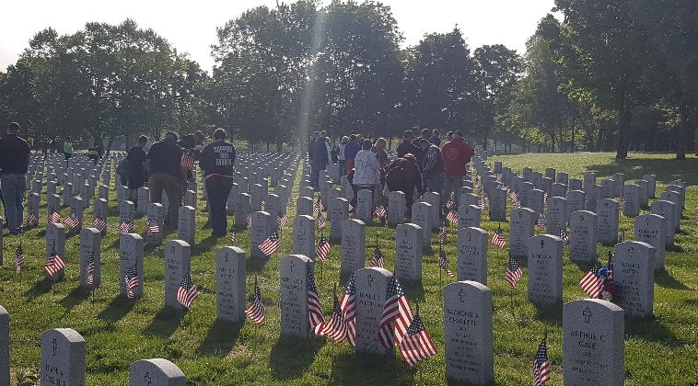

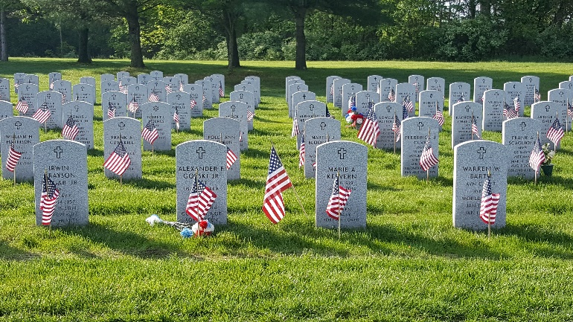

Annual Golf Tournament

Operation Adopt a Soldier hosted its 4th Annual Golf Tournament on Saturday, June 1st at Airway Meadows in Gansevoort NY. It was a nice day and 30 people came to support our cause. Not what we were hoping for, but to each of those people, we thank you. And a big shout out to Tim and Sherry for chairing the event!

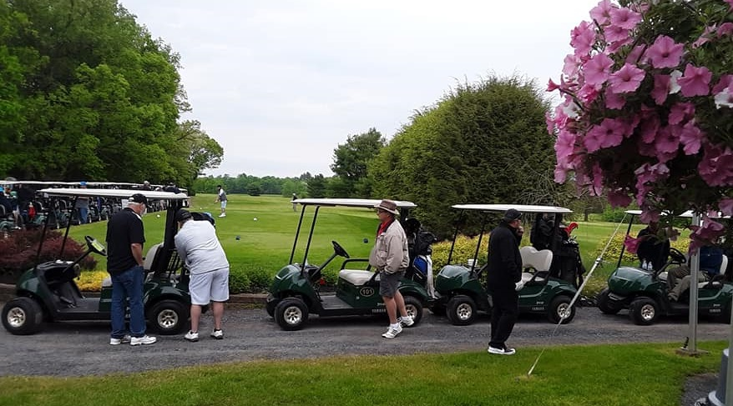

Save the Dates:

6th Annual OAAS Skeet Shoot
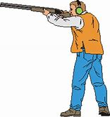
Save the Date ~
July 21, 2019

OAAS will be holding our 6th annual skeet shoot at Hudson Falls Fish & Game Club, 1420 Rte. 196, Hudson Falls, NY. $5 per round of skeet, trap and five-stand. You provide your own ammo, gun, and eye/hearing protection. Food will be served around 11 am and includes grilled hamburgers, hotdogs, and salads. Raffles, 50/50 and gift baskets too! Contact Jason at 518-935-7859 for details. Hope to see you there!

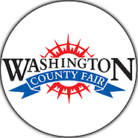
Washington County Fair
Save the Date ~
August 19~25, 2019

Once again, we’ll be at the fair selling tee-shirts, stickers, and spreading the word about our organization. Face painting too, so stop by with the kids! We’ll be at our normal spot across from the 4-H booth. Hope to see you there!

Bus Trip to Foxwoods

Save the Date ~
September 15th, 2109

We’re going to Foxwoods! Yes, that’s right.

$40.00 PER PERSON INCLUDES:
RIDE-TO AND FROM Foxwoods Casino.

$10 FREE PLAY and FREE buffet.

We play BINGO and games on the way to Connecticut.

We will be leaving Wilton Mall near Dick’s Sporting Goods-
Light Pole C-2 at 6:30am Sharp!

YOU MUST BE PAID BY August 26, 2019 OR you will be taken off the list.

For reservations or details call: Cliff at 518-260-9922 or Sherry at 518-522-2472 or Sharon 518-935-7549

Ways to Donate:

Want to Donate? Listed below are several easy ways.

We are always in need of items to send overseas. Done with the new book? Cleaning out your kitchen cabinet of impulse buys? On a diet for the new year? Consider donating them to OAS. A few of the many items that are requested by our soldiers stationed overseas: toothpaste, wet wipes, lotions, books, stationary, hard candy, deodorant, chaps tick, spaghetto’s, razors, gum, journals, pens, magazines, Q-tips, sun screen, band-aids, trail mix, etc. See our website for a detailed list.

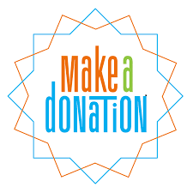

- Amazon Smile: Shop on Amazon Smile (smile.amazon.com) and they will donate 0.5% of the price of eligible purchases to the charitable organization selected by you. And remember in November Amazon starts their Black Friday Deals!

- Drop us a Check in the mail. Our address is:
Operation Adopt a Solder
4281 Rt. 50
Saratoga Springs, NY 12866

- Gather food, personal products, books, and DVDs from your friends and coworkers and drop them off at our building. For a complete list of items needed go to our website.

- GE Matching Gifts Program: Available to GE employees and retirees in their personal donations to charities. Donate $25 or more and then register your gift on the matching gifts web site that is available via GEBENEFITS.COM under the additional benefits heading. First timers must register their email address and receive confirmation. Forward this to Cliff at wiseeagle1@yahoo.com and he’ll watch for your check. Not computer savvy? Then call 1-800-305-0669 and have your SSo# ready to register by telephone.

Volunteer
Bored with life? Feel like you should be giving back? Then look no farther! We are always looking for volunteers to help with our events and pack ups. Don’t have time? Then donations are always good too, lol! Each package we send overseas costs of $15.00 in postage. Yes, $15!! Then multiply that by the number of packages we send. Cost of doing “business”. And Yikes!! So, every dollar counts!
Just hit up our improved website,
www.operationadoptasoldier.org to donate or learn how to volunteer!
And remember!
You can always follow us on Facebook, Twitter, or Snapchat or Find Us on Instagram!

