In This Issue:
- NEW ADDRESS
- Military Ornaments for sale
- November Happenings
- Santa for a Soldier
- December events
- Save the Dates
- Donate
- Volunteer

Hello everyone!
Can you believe it’s December already? November was a very busy month at OAAS. We had our Honor our Veteran’s Brunch at Fortune’s in Saratoga and we have shipped over 1100 care packages to our troops! Yes, 1100 packages in one month! And December will be even busier in the packing and shipping department! Thank you to all who helped! And as always, God bless our Troops!

O

ur next Monthly Meeting will be held on Monday, December 9th at 6:30 pm at our NEW LOCATION at 891 Saratoga Road in Wilton. This is the old Farrell Oil warehouse building at the corner of Rt. 9 & Ballard Road at the base of Wilton Mountain near exit 16. Doors are located near the back so please drive around the building. The next Board of Director’s meeting will be Wednesday, December 11th at 6:30pm. Anyone interested in helping our deployed soldiers or volunteering, come on down!

Support Operation Adopt A Soldier this Christmas! We are now taking orders for our branches of military ornaments. Order ASAP (before December 16th) for guaranteed Christmas delivery. They are $10 a piece or $45 for 5! Contact Cliff Seguin for orders!
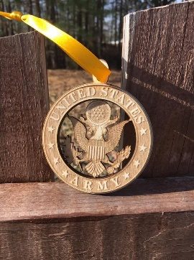
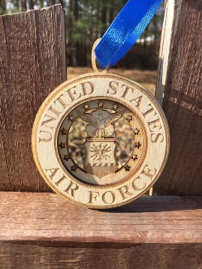
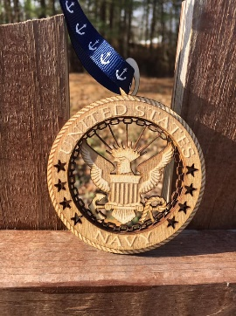

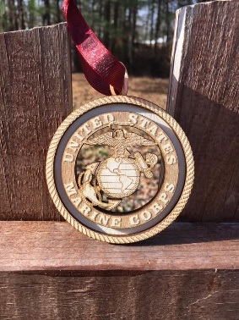
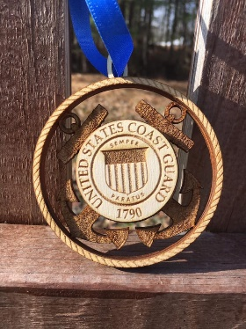

November Happenings:
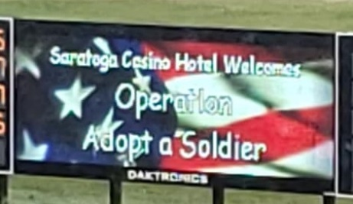
Veteran’s Day Brunch
On Sunday, November 11th OAAS hosted the 6th “Honor our Veteran’s Brunch” at Fortunes at Saratoga Casino and Hotel. The restaurant was full of veterans and their families from all branches of the military. lunch at Fortunes. Funds were raised in many ways, including tickets to the lunch, two tables full of raffle prizes, a 50/50 raffle, and a silent auction. Thank you to the 300+ people who supported us and attended. Hope to see you there, next year!
Packages ready to ship!

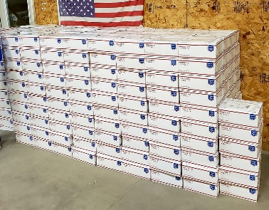
Just before Thanksgiving, OAAS packed up & shipped out 386 care packages for troops deployed overseas. With the holiday season here, MANY more pack-ups will be in our future. And with our Wal-Mart food drives in December we’ll be busy!

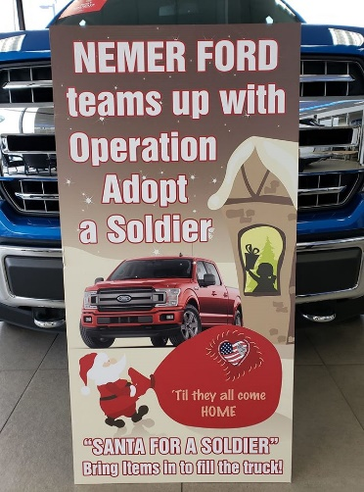
Santa for a Soldier

Once again Operation Adopt a Soldier and Nemer Ford will be teaming up. From now through Tuesday, December 24th, when you make a monetary donation to Operation Adopt a Soldier, Nemer will match up to $10,000!! That’s right, your donation will be doubled thanks to Nemer! Also, both will be at the Walmart on Rte. 9 in Queensbury to collect donations on December 15th from 10 to 4. If you would like to drop off at the dealership you can do that as well. Also, if you'd like to volunteer to help collecting donations that would be awesome. Hope to see you all there!

December Events:

Wal-Mart Donation Drive

Dec. 15th
This Photo by Unknown Author is licensed under CC BY-SA-NC
^{10:00 – 4:00}

Operation Adopt A Soldier & Nemer Ford will be at the Wal-Mart on Route 9 in Queensbury collecting items to ship out to our troops for the holidays. See above!

Ways to Donate:

Want to Donate? Listed below are several easy ways.

We are always in need of items to send overseas. Done with the new book? Cleaning out your kitchen cabinet of impulse buys? On a diet for the new year? Consider donating them to OAS. A few of the many items that are requested by our soldiers stationed overseas: toothpaste, wet wipes, lotions, books, stationary, hard candy, deodorant, chaps tick, spaghetto’s, razors, gum, journals, pens, magazines, Q-tips, sun screen, band-aids, trail mix, etc. See our website for a detailed list.

- Amazon Smile: Shop on Amazon Smile (smile.amazon.com) and they will donate 0.5% of the price of eligible purchases to the charitable organization selected by you. And remember in November Amazon starts their Black Friday Deals!

- Drop us a Check in the mail. Our address is:
Operation Adopt a Solder
4281 Rt. 50
Saratoga Springs, NY 12866

- Gather food, personal products, books, and DVDs from your friends and coworkers and drop them off at our building. For a complete list of items needed go to our website.

- GE Matching Gifts Program: Available to GE employees and retirees in their personal donations to charities. Donate $25 or more and then register your gift on the matching gifts web site that is available via GEBENEFITS.COM under the additional benefits heading. First timers must register their email address and receive confirmation. Forward this to Cliff at wiseeagle1@yahoo.com and he’ll watch for your check. Not computer savvy? Then call 1-800-305-0669 and have your SSo# ready to register by telephone.

Volunteer
Bored with life? Feel like you should be giving back? Then look no farther! We are always looking for volunteers to help with our events and pack ups. Don’t have time? Then donations are always good too, lol! Each package we send overseas costs of $15.00 in postage. Yes, $15!! Then multiply that by the number of packages we send. Cost of doing “business”. And Yikes!! So, every dollar count!
Just hit up our website,
www.operationadoptasoldier.org to donate or learn how to volunteer!
And remember!
You can always follow us on Facebook, Twitter, or Snapchat or Find Us on Instagram!

