In This Issue:
- Package update
- April Bus Trip
- Memorial Day Saratoga National Cemetery
- June 1st Golf Event
- Save the Dates
- Donate
- Volunteer

Hello everyone!
Happy May!! By now everyone has had their Easter dinner, and Memorial Day is at the end of the month. OAAS will be at Saratoga National Cemetery for the Flag event. Sign up now for the June 1st Golf event cause, “We need golfers!” And as always, “God bless our troops!”.

O
ur Monthly Meeting will be held at our building on Monday, May 6th at 6:30 pm. Our next meeting will be June 3rd. Our next Board of Director’s meeting for this year will be Wednesday, June 12th at 6:30pm. Anyone interested in helping our deployed soldiers or volunteering, come on down! We can always use the help!

Package Update:

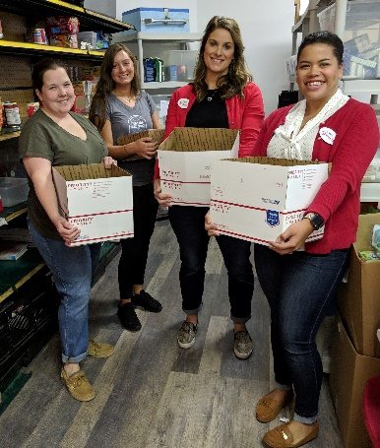
The first quarter of the year is over and we’re heading into May. Our building renovations are completed and OAAS was able to do two pack-ups in April, the first we’ve done this year. On Thursday, April 18th and one on Tuesday, April 30th. Below is a picture from the April 30th pack-up. These ladies boxed up the donations from their Target store. With both pack-ups, we sent out a total of 170 boxes of goodies, with a mailing cost of $ 1,878.05. If you didn’t know, the U.S. Postal Service raised their rates, and added an extra zone, in January. So now we’re paying a little bit more per box to ship. I know that doesn’t sound like a lot, but when you send out thousands of boxes a year, it’s a substantial increase! Any donations are greatly appreciated. See below, under the Donation header, to see what is needed.

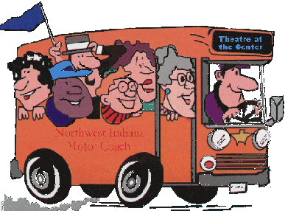
Our bus Trip to Turning Stone
This Photo by Unknown Author is licensed under CC BY-SA-NC

On April 28th, OAAS took 3 buses to Turning Stone Casino in Verona, NY. What a wonderful day it was. On the way out, we kept the casino-goers busy playing Bingo and What’s in your Wallet or Purse. Once there, everyone dispersed and went merrily on their way. We had winners. We had losers. And at the end of the day we had tired bus-goers. The way home was filled with more Bingo games, movies, quiet chatter, and sleepy people. For those who like our trips, then save the date of Sunday, September 15th, cause we’re going to Mohegan Sun! More details next month.

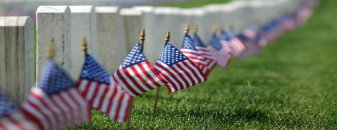
Saratoga National Cemetery
This Photo by Unknown Author is licensed under CC BY-SA
Saturday, May 25th
7:30 am

Operation Adopt a Soldier joining hundreds of volunteers to place flags on our fallen heroes’ graves at the Gerald B.H. Solomon Saratoga National Cemetery. After an opening ceremony, volunteers will place over 18,000 flags on the graves of our fallen heroes. A great way to teach younger children that Memorial Day is not about picnics and barbeques. It is about respecting those who gave their lives. We will be in section 6 and hope to see you there.

Save the Dates:

This Photo by Unknown Author is licensed under CC BY-NC
WE NEED GOLFERS!!!

Annual Golf Tournament
Save the Date ~
June 1, 2019

Operation Adopt a Soldier is hosting its 4th Annual Golf Tournament on Saturday, June 1st at Airway Meadows, 262 Brownville Rd., Gansevoort NY. Check in at 7:15 am. $70/ person with four-person scramble. Includes: 18 holes of golf with a cart and a light lunch. Beverages for sale on the course and ALL proceeds help support our troops. Prizes for men and women for hole in one, closet to the pin, longest drive, and putting contest. Make sure to call and reserve your spots, they will fill up quick! All proceeds go to OAAS. Call Tim at 518-791-5270 or email him at ratherbgolfing247@roadrunner.com to reserve your spot or ask any questions. All Money DUE BY May 20, 2018. Hope to see you there!
Washington County Fair
Save the Date ~
August 19~25, 2019

Once again, we’ll be at the fair selling tee-shirts, stickers, and spreading the word about our organization. Face painting too, so stop by with the kids! We’ll be at our normal spot across from the 4-H booth. Hope to see you there!

Ways to Donate:

Want to Donate? Listed below are several easy ways.

We are always in need of items to send overseas. Done with the new book? Cleaning out your kitchen cabinet of impulse buys? On a diet for the new year? Consider donating them to OAS. A few of the many items that are requested by our soldiers stationed overseas: toothpaste, wet wipes, lotions, books, stationary, hard candy, deodorant, chaps tick, spaghetto’s, razors, gum, journals, pens, magazines, Q-tips, sun screen, band-aids, trail mix, etc. See our website for a detailed list.

- Amazon Smile: Shop on Amazon Smile (smile.amazon.com) and they will donate 0.5% of the price of eligible purchases to the charitable organization selected by you. And remember in November Amazon starts their Black Friday Deals!

- Drop us a Check in the mail. Our address is:
Operation Adopt a Solder
4281 Rt. 50
Saratoga Springs, NY 12866

- Gather food, personal products, books, and DVDs from your friends and coworkers and drop them off at our building. For a complete list of items needed go to our website.

- GE Matching Gifts Program: Available to GE employees and retirees in their personal donations to charities. Donate $25 or more and then register your gift on the matching gifts web site that is available via GEBENEFITS.COM under the additional benefits heading. First timers must register their email address and receive confirmation. Forward this to Cliff at wiseeagle1@yahoo.com and he’ll watch for your check. Not computer savvy? Then call 1-800-305-0669 and have your SSo# ready to register by telephone.

Volunteer
Bored with life? Feel like you should be giving back? Then look no farther! We are always looking for volunteers to help with our events and pack ups. Don’t have time? Then donations are always good too, lol! Each package we send overseas costs of $15.00 in postage. Yes, $15!! Then multiply that by the number of packages we send. Cost of doing “business”. And Yikes!! So, every dollar counts!
Just hit up our improved website,
www.operationadoptasoldier.org to donate or learn how to volunteer!
And remember!
You can always follow us on Facebook, Twitter, or Snapchat or Find Us on Instagram!

