In This Issue:
- NEW ADDRESS
- Orvis Fly Rod Raffle
- September Event results
- October happenings
- Save the Dates
- Donate
- Volunteer

Hello everyone!

It’s October and that means Halloween! WE NEED HELP!! Badly! If you have any free time in the next few weeks, please head on over to the woods behind Gavin Park in Wilton and help us get ready for the Harvest Event, our biggest fundraiser of the year. Also, tickets are on sale now for our Honor our Veteran’s Brunch.

O
ur next Monthly Meeting will be held on Monday, November 4th at 6:30 pm at our NEW LOCATION at 891 Saratoga Road in Wilton. This is the old Farrell Oil warehouse building at the corner of Rt. 9 & Ballard Road at the base of Wilton Mountain near exit 16. Doors are located near the back so please drive around the building. The next Board of Director’s meeting will be Wednesday, December 11th at 6:30pm. Anyone interested in helping our deployed soldiers or volunteering, come on down! We are starting to get our woods ready for haunting. We need volunteers to clean up the woods and build haunts. If you and a few of your friends are Halloween enthusiasts and love to create eerie and scary props, then we need you! We’re always looking for new ideas!

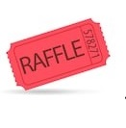
Orvis Fly Rod & Reel Raffle

Operation Adopt a Soldier is holding a new raffle! The winner will receive a NEW ORVIS RECON 9’ 5 Wt. Rod and case with a NEW Battenkill Disc II Reel. That’s a $400+ value. And the best thing, tickets are only $5. That’s right, $5. And we’re only selling 200 tickets. The raffle drawing will be held on November 10, 2019 at our Honor our Veteran’s Brunch at Fortune’s Restaurant at the Saratoga Casino and Hotel. If you would like to buy a raffle ticket, you can send a SASE, with a check for $5 and a note stating you would like to buy a raffle, and we’ll send you your ticket. You can also contact Cliff at 518-260-9922.

September Happenings:

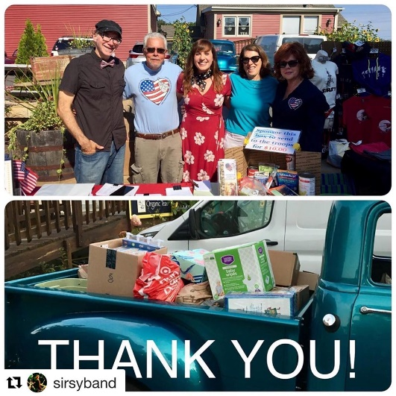
Photos from the Sirsy concert on Sunday September 22nd at Wicked Eatery. We raised about $4,000 worth of donated items plus $1,230 in cash which allows OAS to send multiple boxes to our troops! Thank you for your support!!

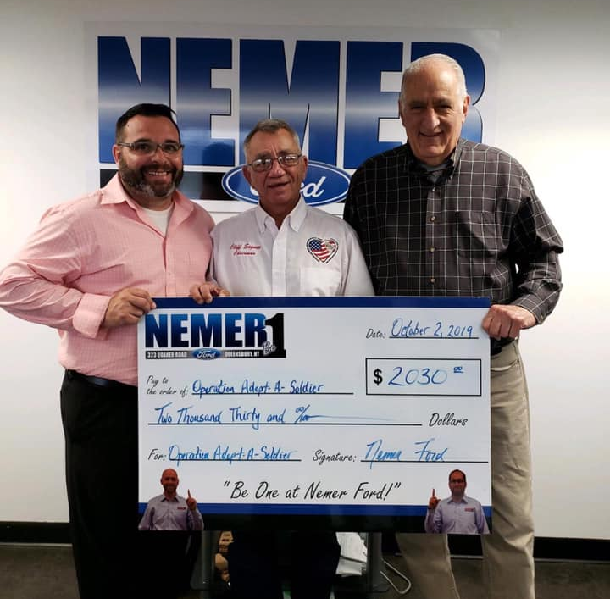
A big shout out to Shawn Leombruno and everyone at Nemer Ford for your support. On Sunday, September 29th, Shawn, along with OAS’s Bruce Duxbury and Jason Gilbert, spent the day at the Rt.9 Queensbury Walmart. Nemer Ford was matching any donations that went into our 5-gallon jug. They handed out fliers, collected monetary donations, canned goods and needed items that were lost in our fire. And on Monday, October 2nd, they presented Cliff with a check for $2,030.00. Everyone at OAS wants to thank you, Shawn, and Nemer Ford, for what you do.

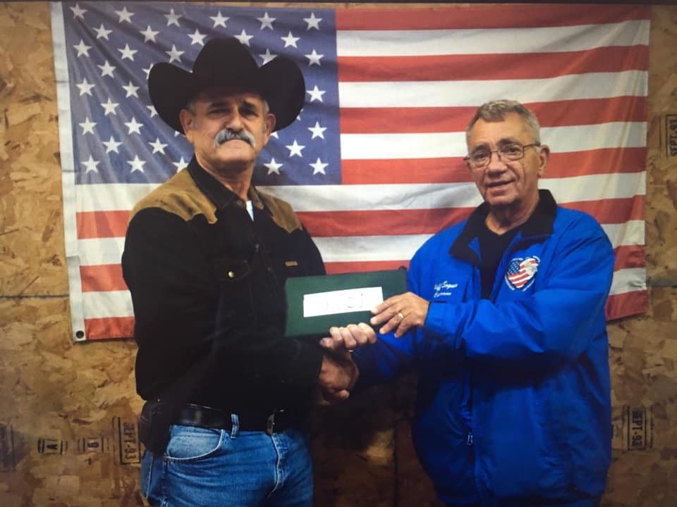
Phil Hoyt stopped by Operation Adopt a Soldier on Monday, October 7th and presented Cliff with a check for $4,051.00 from his annual concert. What an amazing job by Phil and his family. Everyone at OAS wants to thank you and yours for the dedication and hard work that you do.

October Events:

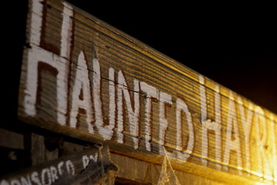
OAAS & John Vincek Memorial Haunted Hayride
This Photo by Unknown Author is licensed under CC BY-NC
Save the Date ~
October 18th, 19th, 25th, 26th, 2019

5 pm to 10 pm at Gavin Park (10 Lewis Dr), Wilton NY
The John Vincek Memorial Haunted Hayride
presented by Operation Adopt a Soldier will be here before you know it. 4pm to 6pm is the “Little
Screamers” hayride when there are no scary beings
in the woods. The spookiness starts at dark. There
will also be games in the gym (tickets sold
separately), a bounce house and costume judging at 7 pm. PROCEEDS WILL BENEFIT THE JOHN VINCEK MEMORIAL FUND
and OPERATION ADOPT A SOLDIER. Sponsored
by Vincek Farms and John Ariel Farm. The cost is
just $8 for the little screamers and $15 for adults. If
you have questions, call Cliff 518-260-9922 or
Sherry 518-522-2472 or Lynette 518-222-1091.

Save the Date:

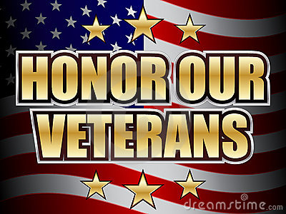
Honor Our Veterans Luncheon
This Photo by Unknown Author is licensed under CC BY-SA
Save the Date ~
November 10th, 2019

Join Operation Adopt a Soldier at our Honor Our Veterans Buffet Brunch held at Fortune’s Restaurant at the Saratoga Casino and Hotel. Come out for a monring filled with good food,; enteratinment and amazing company as we honor all those military men and women who served the USA. There will be basket raffles, a 50/50, and harness horse racing! Tickets are available now so don’t delay. Call Cliff at 518-260-9922 for details.

Ways to Donate:

Want to Donate? Listed below are several easy ways.

We are always in need of items to send overseas. Done with the new book? Cleaning out your kitchen cabinet of impulse buys? On a diet for the new year? Consider donating them to OAS. A few of the many items that are requested by our soldiers stationed overseas: toothpaste, wet wipes, lotions, books, stationary, hard candy, deodorant, chaps tick, spaghetto’s, razors, gum, journals, pens, magazines, Q-tips, sun screen, band-aids, trail mix, etc. See our website for a detailed list.

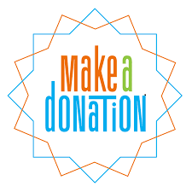

- Amazon Smile: Shop on Amazon Smile (smile.amazon.com) and they will donate 0.5% of the price of eligible purchases to the charitable organization selected by you. And remember in November Amazon starts their Black Friday Deals!

- Drop us a Check in the mail. Our address is:
Operation Adopt a Solder
4281 Rt. 50
Saratoga Springs, NY 12866

- Gather food, personal products, books, and DVDs from your friends and coworkers and drop them off at our building. For a complete list of items needed go to our website.

- GE Matching Gifts Program: Available to GE employees and retirees in their personal donations to charities. Donate $25 or more and then register your gift on the matching gifts web site that is available via GEBENEFITS.COM under the additional benefits heading. First timers must register their email address and receive confirmation. Forward this to Cliff at wiseeagle1@yahoo.com and he’ll watch for your check. Not computer savvy? Then call 1-800-305-0669 and have your SSo# ready to register by telephone.

Volunteer
Bored with life? Feel like you should be giving back? Then look no farther! We are always looking for volunteers to help with our events and pack ups. Don’t have time? Then donations are always good too, lol! Each package we send overseas costs of $15.00 in postage. Yes, $15!! Then multiply that by the number of packages we send. Cost of doing “business”. And Yikes!! So, every dollar count!
Just hit up our website,
www.operationadoptasoldier.org to donate or learn how to volunteer!
And remember!
You can always follow us on Facebook, Twitter, or Snapchat or Find Us on Instagram!

