In This Issue:
- NEW ADDRESS
- Orvis Fly Rod Raffle
- October Event results
- November happenings
- Save the Dates
- Donate
- Volunteer

Hello everyone!
November is here and the holidays are right around the corner. And that means it’s our busiest time of the year to send packages. Remember, not everyone comes home for the holidays. Our Honor our Veteran’s Brunch is in a few days. Get your tickets now as they’re $5 more at the door. And as always, God bless our Troops!

O
ur next Monthly Meeting will be held on Monday, December 2nd at 6:30 pm at our NEW LOCATION at 891 Saratoga Road in Wilton. This is the old Farrell Oil warehouse building at the corner of Rt. 9 & Ballard Road at the base of Wilton Mountain near exit 16. Doors are located near the back so please drive around the building. The next Board of Director’s meeting will be Wednesday, December 11th at 6:30pm. Anyone interested in helping our deployed soldiers or volunteering, come on down!

Orvis Fly Rod & Reel Raffle – to be drawn in less than a week!

Operation Adopt a Soldier is holding a new raffle! The winner will receive a NEW ORVIS RECON 9’ 5 Wt. Rod and case with a NEW Battenkill Disc II Reel. That’s a $400+ value. And the best thing, tickets are only $5. That’s right, $5. And we’re only selling 200 tickets. The raffle drawing will be held on November 10, 2019 at our Honor our Veteran’s Brunch at Fortune’s Restaurant at the Saratoga Casino and Hotel. If you would like to buy a raffle ticket, you can send a SASE, with a check for $5 and a note stating you would like to buy a raffle, and we’ll send you your ticket. You can also contact Cliff at 518-260-9922.

October Happenings:

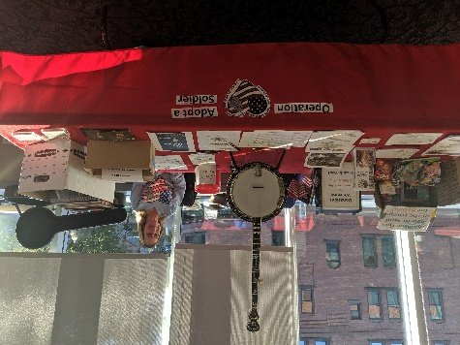
October 5th….
Saratoga Guitar celebrated its 25th anniversary with a ree concert and party at the Saratoga City Center. Owner Matt McCabe donated a 1984 Deering GDL 5 string banjo to be auctioned off by Operation Adopt a Soldier.

OAAS & John Vincek Memorial Haunted Hayride

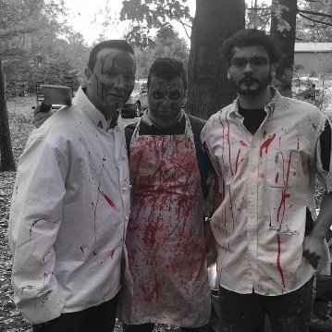
The 2019 Harvest event was a giant success! We had 4 nights, well, 3 with nice weather. One was a little damp, but we still sent out 9 wagons of scare seekers. It was probably one of our best seasons yet and we can’t wait until next year! A huge thanks to Tim, Sherry, Cliff, Bruce, Jason, Susan, our famous headless horseman, Gil, and everyone else that helped. We couldn’t do this with out our volunteers and all their hard-dedicated work. See you in 2020!

November Events:

Honor our Veterans Brunch
November 10th, 2019

Join Operation Adopt a Soldier at our Honor Our Veterans Buffet Brunch held at Fortune’s Restaurant at the Saratoga Casino and Hotel. Come out for a monring filled with good food,; enteratinment and amazing company as we honor all those military men and women who served the USA. There will be basket raffles, a 50/50, and harness horse racing! Limited tickets are still available now so don’t delay. $30 advance/ $35 at door. Call Cliff at 518-260-9922 for details.
Wal-Mart Donation Drive

Nov 24th, Dec. 1st, 8th, 15th, & 22nd
This Photo by Unknown Author is licensed under CC BY-SA-NC

Operation Adopt A Soldier will be at the Wal-Mart on Route 9 in Queensbury collecting items to ship out to our troops for the holidays. Stop by and say hi!

Ways to Donate:

Want to Donate? Listed below are several easy ways.

We are always in need of items to send overseas. Done with the new book? Cleaning out your kitchen cabinet of impulse buys? On a diet for the new year? Consider donating them to OAS. A few of the many items that are requested by our soldiers stationed overseas: toothpaste, wet wipes, lotions, books, stationary, hard candy, deodorant, chaps tick, spaghetto’s, razors, gum, journals, pens, magazines, Q-tips, sun screen, band-aids, trail mix, etc. See our website for a detailed list.

- Amazon Smile: Shop on Amazon Smile (smile.amazon.com) and they will donate 0.5% of the price of eligible purchases to the charitable organization selected by you. And remember in November Amazon starts their Black Friday Deals!

- Drop us a Check in the mail. Our address is:
Operation Adopt a Solder
4281 Rt. 50
Saratoga Springs, NY 12866

- Gather food, personal products, books, and DVDs from your friends and coworkers and drop them off at our building. For a complete list of items needed go to our website.

- GE Matching Gifts Program: Available to GE employees and retirees in their personal donations to charities. Donate $25 or more and then register your gift on the matching gifts web site that is available via GEBENEFITS.COM under the additional benefits heading. First timers must register their email address and receive confirmation. Forward this to Cliff at wiseeagle1@yahoo.com and he’ll watch for your check. Not computer savvy? Then call 1-800-305-0669 and have your SSo# ready to register by telephone.

Volunteer
Bored with life? Feel like you should be giving back? Then look no farther! We are always looking for volunteers to help with our events and pack ups. Don’t have time? Then donations are always good too, lol! Each package we send overseas costs of $15.00 in postage. Yes, $15!! Then multiply that by the number of packages we send. Cost of doing “business”. And Yikes!! So, every dollar count!
Just hit up our website,
www.operationadoptasoldier.org to donate or learn how to volunteer!
And remember!
You can always follow us on Facebook, Twitter, or Snapchat or Find Us on Instagram!

