In This Issue:
- October happenings – Harvest Event
- November Events
- Save the Dates
- Donate
- Volunteer

Happy November everyone!

Well, the leaves have changed color and are hitting the ground. November is here, Veteran’s Day is around the corner and then it’s Thanksgiving. Tickets are on sale now for our Honor our Veterans Brunch on November 11th at Fortunes restaurant at Saratoga Casino. Don’t forget to check out our Save-the-dates. And as always, “God bless our troops!”.

O
ur Monthly Meeting was be held at our building (4281 Rte. 50, Wilton) on Monday, November 5th at 6:30 pm. Out next pack will be announced soon. Anyone interested in helping our deployed soldiers or volunteering, come on down! We can always use the help!

October’s happenings:

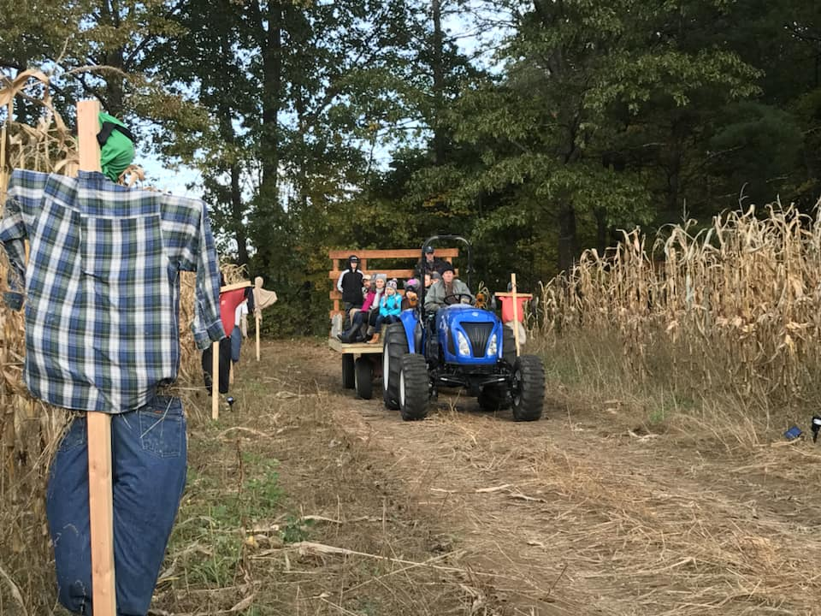
The John Vincek Memorial Haunted Hayride presented by Operation Adopt a Soldier was a smashing success! We had over 3 awesome nights filled with hundreds of people and their littles riding through the woods and getting spooked. Unfortunately, the last Saturday night’s hayride was cancelled due to the inclement weather, but the gym was in full swing. By the last night, over 1500 people had set their selves down on bales of hay, and traveled through our woods, on our wagons. They were even terrorized by our headless horseman! A great time was had by everyone! Thank you to all that helped “haunt” our woods and came out in support. We had a blast and hope to see you next year!
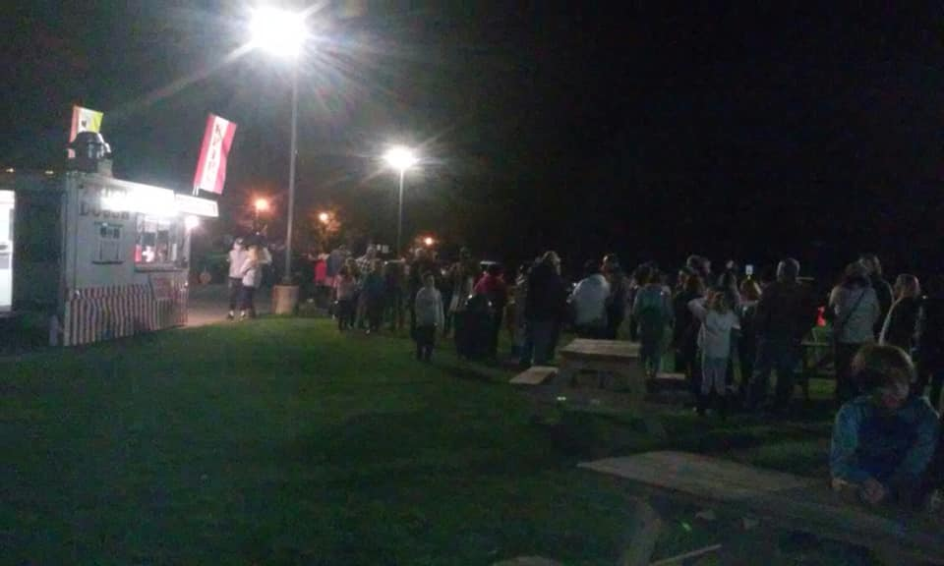

November’s Events:
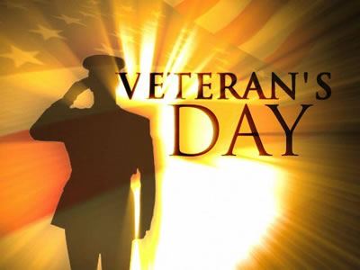
Honor Our Veterans Luncheon
Save the Date ~

November 11th

Join Operation Adopt a Soldier at our Honor Our Veterans Buffet Brunch held at Fortune's Restaurant at Saratoga Casino and Hotel. Come out for a morning filled with good food, entertainment, and amazing company as we honor all those military men and women who served the USA. There will be basket raffles, 50/50, and harness horse racing!
The cost is $25 per ticket or $30 at the door. We suggest purchasing tickets a head of time.
Tickets are on sale now!! Call Mary at 518-495-6613.
Hope to see you there!

On November 18th we’ll be marching in the South Glens Falls Holiday Parade. Watch for our “Float”.

Save the Dates:
This Photo by Unknown Author is licensed under CC BY-NC
Annual Golf Tournament
Save the Date ~
June 1, 2019

For details call Tim at 518-791-5270 or email ratherbgolfing247@roadruner.com

Ways to Donate:

Want to Donate? Listed below are several easy ways.

We are always in need of items to send overseas. Done with the new book? Cleaning out your kitchen cabinet of impulse buys? On a diet for the new year? Consider donating them to OAS. A few of the many items that are requested by our soldiers stationed overseas: toothpaste, wet wipes, lotions, books, stationary, hard candy, deodorant, chaps tick, spaghetto’s, razors, gum, journals, pens, magazines, Q-tips, sun screen, band-aids, trail mix, etc. See our website for a detailed list.

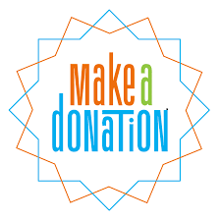

- Amazon Smile: Shop on Amazon Smile (smile.amazon.com) and they will donate 0.5% of the price of eligible purchases to the charitable organization selected by you. And remember in November Amazon starts their Black Friday Deals!

- Drop us a Check in the mail. Our address is:
Operation Adopt a Solder
4281 Rt. 50
Saratoga Springs, NY 12866

- Gather food, personal products, books, and DVDs from your friends and coworkers and drop them off at our building. For a complete list of items needed go to our website.

- GE Matching Gifts Program: Available to GE employees and retirees in their personal donations to charities. Donate $25 or more and then register your gift on the matching gifts web site that is available via GEBENEFITS.COM under the additional benefits heading. First timers must register their email address and receive confirmation. Forward this to Cliff at wiseeagle1@yahoo.com and he’ll watch for your check. Not computer savvy? Then call 1-800-305-0669 and have your SSo# ready to register by telephone.

Volunteer
Bored with life? Feel like you should be giving back? Then look no farther! We are always looking for volunteers to help with our events and pack ups. Don’t have time? Then donations are always good too, lol! Each package we send overseas costs of $15.00 in postage. Yes, $15!! Then multiply that by the number of packages we send. Cost of doing “business”. And Yikes!! So, every dollar counts!
Just hit up our improved website,
www.operationadoptasoldier.org to donate or learn how to volunteer!
And remember!
You can always follow us on Facebook, Twitter, or Snapchat or Find Us on Instagram!

