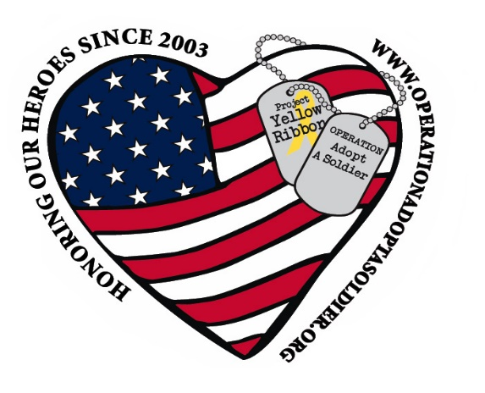
Operation Adopt a Soldier
ARTS AND CRAFTS VENDOR FAIR
Saturday April 18, 2020 9 to 3pm
891 Saratoga Rd Gansevoort, NY 12831

Return application and fee (checks made out to Operation Adopt a Soldier) by Mar 15th.
Space will be 12’ X 12’ for $50.00 Spaces will be assigned. Both indoor and outdoor spaces are available.
Vendor is responsible for providing table and chairs (cover if outside)
Arrival for set up is 8 am
Operation Adopt a soldier is not responsible for your sales tax. Each vendor is responsible for reporting their own sales tax
No alcohol or pets allowed on premises

Cancellation Policy
Cancel anytime up to 1 month prior to event date with full refund, 15-29 days prior half refund, 1-15 days prior to event no refund.

Any questions please call or text Sherry at 518-522-2472

Operation Adopt a Soldier
ARTS AND CRAFTS VENDOR FAIR
Saturday April 18, 2020 9 to 3pm
891 Saratoga Rd Gansevoort, NY 12831
APPLICATION FOR VENDORS

NAME: ___________________________________________________________
BUSINESS NAME: __________________________________________________
ADDRESS: _________________________________________________________
_________________________________________________________

PHONE NUMBER: ___________________________________________________
EMAIL: ____________________________________________________________
CRAFT/VENDOR PRODUCT: ____________________________________________

I have read and understand the cancellation policy.

SIGNATURE:________________________________________________________

