In This Issue:
- Package update
- Printer Donation
- April Bus Trip
- Open House & Garage Sale
- Save the Dates
- Donate
- Volunteer

Hello everyone!

Well, it’s April. Spring is here and before we know it, our shades of brown will be gone! We’ll be having an open house and garage sale on April 14th! Stop in and have a look at our newly renovated building. And as always, “God bless our troops!”.

O
ur Monthly Meeting was held at our building on Monday, April 1st. Our next meeting will be May 6th at 6:30 pm. Our next Board of Director’s meeting for this year will be Wednesday, June 12th at 6:30pm. Anyone interested in helping our deployed soldiers or volunteering, come on down! We can always use the help!

Package Update:

Due to the renovations at our building we were unable to send out any packages in March.

Printer Donation

Recently, Operation Adopt a Soldier received a grant for the purchase of a new laser printer/copier. This printer will be used to print out the many shipping labels, fliers and various letters that we do every month. A big thank you goes out to Charlie Wheeler, past president of the Saratoga Springs Rotary, for the help he gave Co-chairman Bruce Duxbury for making this happen!

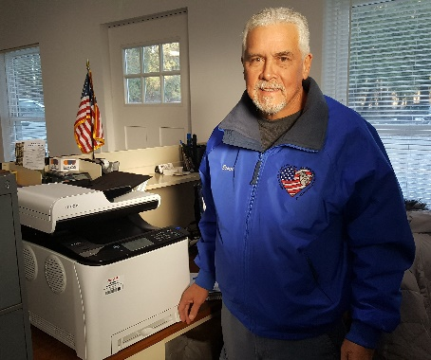
Co-Chair Bruce Duxbury, shown next to our newly donated printer.

Bus Trip to Turning Stone

April 28, 2019

ATTENTION BINGO PLAYERS!!!

Turning Stone is having a special Bingo event on this day. Each Regular game pays out $10,000 and their Jackpot pays out $25,000! There are 3 price levels you will pay at the door. Level 1 - $99. Level 2 - $149. Level 3 - $199. YOU MUST SIGN UP, ONLINE, IN ADVANCE TO GUARANTEE YOUR SPOT.

We will be leaving Wilton Mall near Dick’s Sporting Goods-
Light Pole C-2 at 6:30am Sharp!

$35.00 PER PERSON INCLUDES:
RIDE-TO AND FROM Turning Stone Casino.

$25.00 FREE PLAY

We play BINGO and games on the way out to Verona.

YOU MUST BE PAID BY April 10, 2019 OR you will be taken off the list.

For reservations or details call: Cliff at 518-260-9922 or Sherry at 518-522-2472

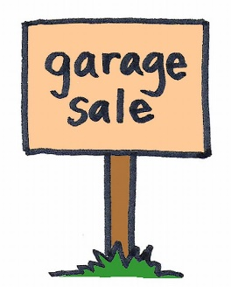
ATTENTION
EVERYONE!

April 14, 2019

Operation Adopt a Soldier will be having an Open House and Garage Sale at our building on Saturday, April 14th, 9 am to 5 pm. Come on down and have a look at our newly renovated space and while you’re there pick up some baked goodies and peruse our garage sale tables. A great way to support OAS! Hope to see you there!

Save the Dates:
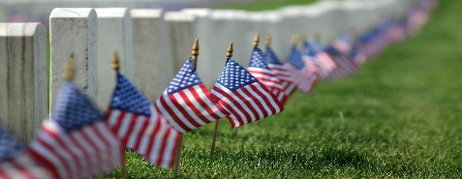
Saratoga National Cemetery
This Photo by Unknown Author is licensed under CC BY-SA
Saturday, May 25th
7:30 am

Operation Adopt a Soldier joining hundreds of volunteers to place flags on our fallen heroes’ graves at the Gerald B.H. Solomon Saratoga National Cemetery. After an opening ceremony, volunteers will place over 18,000 flags on the graves of our fallen heroes. A great way to teach younger children that Memorial Day is not about picnics and barbeques. It is about respecting those who gave their lives. We will be in section 6 and hope to see you there.

This Photo by Unknown Author is licensed under CC BY-NC

Annual Golf Tournament
Save the Date ~
June 1, 2019

For details call Tim at 518-791-5270 or email ratherbgolfing247@roadruner.com

Ways to Donate:

Want to Donate? Listed below are several easy ways.

We are always in need of items to send overseas. Done with the new book? Cleaning out your kitchen cabinet of impulse buys? On a diet for the new year? Consider donating them to OAS. A few of the many items that are requested by our soldiers stationed overseas: toothpaste, wet wipes, lotions, books, stationary, hard candy, deodorant, chaps tick, spaghetto’s, razors, gum, journals, pens, magazines, Q-tips, sun screen, band-aids, trail mix, etc. See our website for a detailed list.

- Amazon Smile: Shop on Amazon Smile (smile.amazon.com) and they will donate 0.5% of the price of eligible purchases to the charitable organization selected by you. And remember in November Amazon starts their Black Friday Deals!

- Drop us a Check in the mail. Our address is:
Operation Adopt a Solder
4281 Rt. 50
Saratoga Springs, NY 12866

- Gather food, personal products, books, and DVDs from your friends and coworkers and drop them off at our building. For a complete list of items needed go to our website.

- GE Matching Gifts Program: Available to GE employees and retirees in their personal donations to charities. Donate $25 or more and then register your gift on the matching gifts web site that is available via GEBENEFITS.COM under the additional benefits heading. First timers must register their email address and receive confirmation. Forward this to Cliff at wiseeagle1@yahoo.com and he’ll watch for your check. Not computer savvy? Then call 1-800-305-0669 and have your SSo# ready to register by telephone.

Volunteer
Bored with life? Feel like you should be giving back? Then look no farther! We are always looking for volunteers to help with our events and pack ups. Don’t have time? Then donations are always good too, lol! Each package we send overseas costs of $15.00 in postage. Yes, $15!! Then multiply that by the number of packages we send. Cost of doing “business”. And Yikes!! So, every dollar counts!
Just hit up our improved website,
www.operationadoptasoldier.org to donate or learn how to volunteer!
And remember!
You can always follow us on Facebook, Twitter, or Snapchat or Find Us on Instagram!

