In This Issue:
- NEW ADDRESS
- Chairman’s Annual Letter
- Military Ornaments for sale
- Santa for a Soldier results
- Save the Dates
- Donate
- Volunteer

Hello everyone!
Happy New Year! As most of you know 2019 held many challenges for OAS and for others. So, hopefully 2020 will be filled with happiness, health and prosperity for all. December was filled with many fund raisers and care packages being sent to our troops overseas. Watch out for our save the dates in the next few months as we begin our 2020 year. And as always, “God bless our troops!”

O

ur next Monthly Meeting will be held on Monday, January 6th at 6:30 pm at our NEW LOCATION at 891 Saratoga Road in Wilton. This is the old Farrell Oil warehouse building at the corner of Rt. 9 & Ballard Road at the base of Wilton Mountain near exit 16. Doors are located near the back so please drive around the building. The next Board of Director’s meeting will be Wednesday, March 11th at 6:30pm. Anyone interested in helping our deployed soldiers or volunteering, come on down!

LETTER FROM CHAIRMAN (CEO)
I would like to take this opportunity to thank everyone, our friends and family, our volunteers, and our supporters for everything that you do. The success of Operation Adopt a Soldier is built on your efforts and in this past year, we have needed you more than ever. Thank you for that dedication, loyalty, and commitment that you have shown OAAS.
As most of you know 2019 was filled with many challenges for our organization. In mid-August we suffered a devasting fire which resulted in a total loss of our newly renovated building. We were now homeless and faced the challenge of finding a suitable space to house ourselves. Donations of every kind poured in, but we had nowhere to put them. A local business kindly donated the use of their warehouse, so we were able to relocate quickly. How reassuring it was to know that our community has our back!
Weeks later, we were also faced with the damages to our hayride trail for our Harvest Event. As most of you know, this is our largest fund raiser of the year. And its success is based largely on our volunteers that spend countless hours building props and setting up the woods. And of course, our “actors” that haunt after dark. Unfortunately, as each year goes by, we have found a decrease in participation. An organization such as ours will always face challenges and the need for new volunteers is just one of many.
As we moved into our busy winter season of mailing care package to our Soldiers for Christmas, I found overwhelming support from our great communities. The shear amount of goods and monetary support was amazing. And I would like to say “THANK YOU, from the bottom of my heart” to each and every one of you - the friends and family, the

people who donated, and the businesses that support us and our mission. Without your support, Operation Adopt a Soldier would not be what it is today. And since the fire, I have found that we have built an honorable organization that is known all over all the states.
As we move into 2020, a new year and a new decade, we will face many more changes and challenges. But we will stand together as a group and we will overcome each and every one of them. Our mission is simple – to support our military and their families as they serve our great country and protect our freedom.
I offer my best wishes and happiness to you and your families as we all look forward to a successful 2020. On behalf of Operation Adopt a Soldier, please allow me to extend my personal and genuine appreciation to each one you for your valuable contributions to this great organization. Working with you this past year has been a pleasure, and I’m proud to have you with me.
Sincerely,
Cliff Seguin Chairman/CEO

We are now taking orders for our branches of military ornaments. They are $10 a piece or $45 for 5! Contact Cliff Seguin for orders!
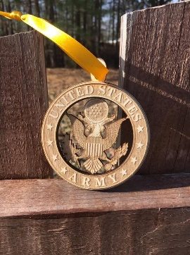
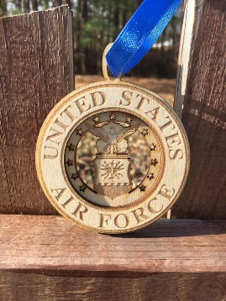
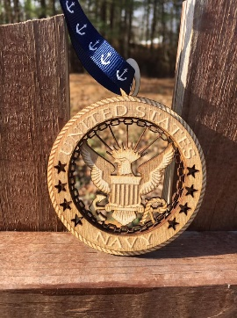
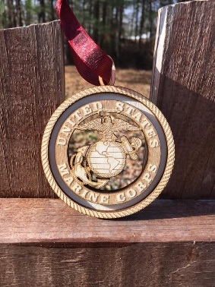
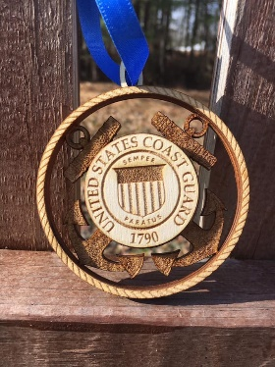

December Happenings
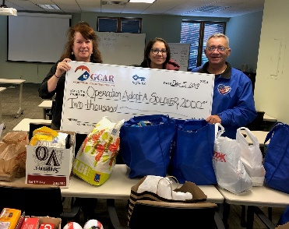
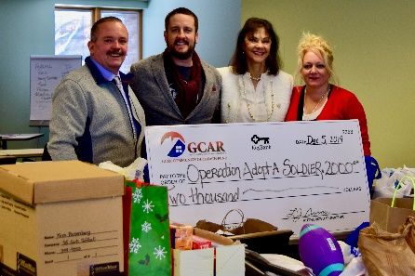

On December 5th, a $2000 check was presented to OAS from Greater Capital Association of REALTORS.

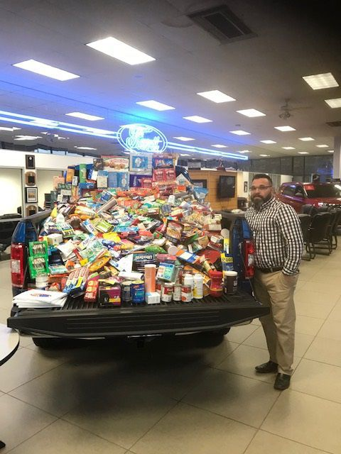
Santa for a Soldier

Once again Operation Adopt a Soldier and Nemer Ford teamed up. Staff and patrons of Nemer Ford filled a pickup truck full of items that were sent to soldiers overseas through an "Adopt-a-Soldier" drive held in December.
Nemer salesmen Shawn Leombruno helped coordinate the drive, which resulted in a Ford pickup full of goods being donated by the dealership.
Shawn also worked with Cliff Seguin and volunteers of OAS to collect donations at the Queensbury Walmart store in December.

Save the Dates

Arts & Crafts Flea Market
Save the Date
April 18th, 2020

Stay tuned for details…

Bus Trip to Turning Stone
Save the Date
April 22, 2020

We will be leaving Wilton Mall near Dick’s Sporting Goods Light Pole –C-2 at 6:30am Sharp!
YOU MUST BE PAID BY April 1st OR you will be taken off the list.

For reservations or details call: Cliff at 518-260-9922 or Sherry at 518-522-2472

Ways to Donate:

Want to Donate? Listed below are several easy ways.

We are always in need of items to send overseas. Done with the new book? Cleaning out your kitchen cabinet of impulse buys? On a diet for the new year? Consider donating them to OAS. A few of the many items that are requested by our soldiers stationed overseas: toothpaste, wet wipes, lotions, books, stationary, hard candy, deodorant, chaps tick, spaghetto’s, razors, gum, journals, pens, magazines, Q-tips, sun screen, band-aids, trail mix, etc. See our website for a detailed list.

- Amazon Smile: Shop on Amazon Smile (smile.amazon.com) and they will donate 0.5% of the price of eligible purchases to the charitable organization selected by you. And remember in November Amazon starts their Black Friday Deals!

- Drop us a Check in the mail. Our address is:
Operation Adopt a Solder
4281 Rt. 50
Saratoga Springs, NY 12866

- Gather food, personal products, books, and DVDs from your friends and coworkers and drop them off at our building. For a complete list of items needed go to our website.

- GE Matching Gifts Program: Available to GE employees and retirees in their personal donations to charities. Donate $25 or more and then register your gift on the matching gifts web site that is available via GEBENEFITS.COM under the additional benefits heading. First timers must register their email address and receive confirmation. Forward this to Cliff at wiseeagle1@yahoo.com and he’ll watch for your check. Not computer savvy? Then call 1-800-305-0669 and have your SSo# ready to register by telephone.

Volunteer
Bored with life? Feel like you should be giving back? Then look no farther! We are always looking for volunteers to help with our events and pack ups. Don’t have time? Then donations are always good too, lol! Each package we send overseas costs of $15.00 in postage. Yes, $15!! Then multiply that by the number of packages we send. Cost of doing “business”. And Yikes!! So, every dollar count!
Just hit up our website,
www.operationadoptasoldier.org to donate or learn how to volunteer!
And remember!
You can always follow us on Facebook, Twitter, or Snapchat or Find Us on Instagram!

